**Cyber Security**

**Assignment Day 4**

**Question 1:**

Find out the mail servers of the following domain:

* Ibm.com
* Wipro.com

-->Open PenTester VMware workstation

-->Open Command Prompt

Type:

www.Ibm.com

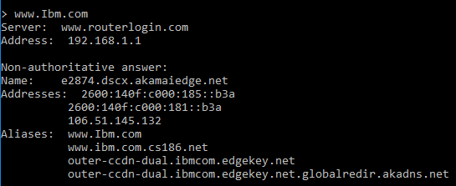

www.Wipro.com

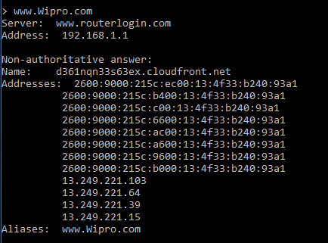

**Question 2:**

Find the locations, where these email servers are hosted.

Type:

---> set type=mx

--->Ibm.com

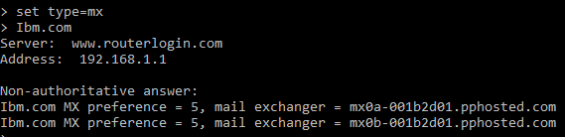

>Open google chrome

>Open IP Location Finder

>Copy paste the url and find the location

**Address 1:**

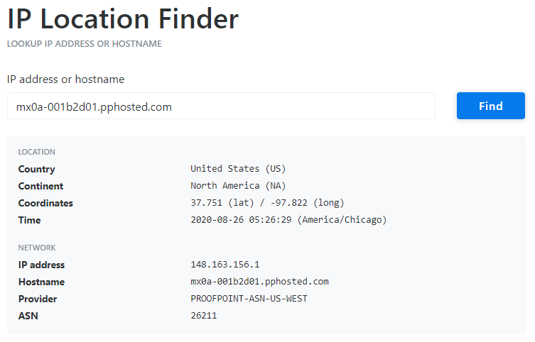

**Address 2:**

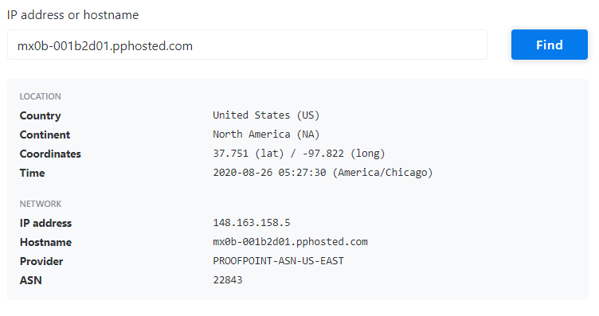

Wipro.com

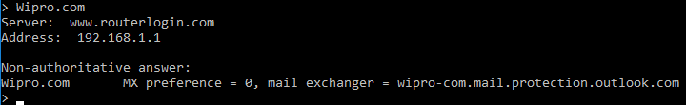

>Open google chrome

>Open IP Location Finder

>Copy paste the URL and find the location

**Address:**

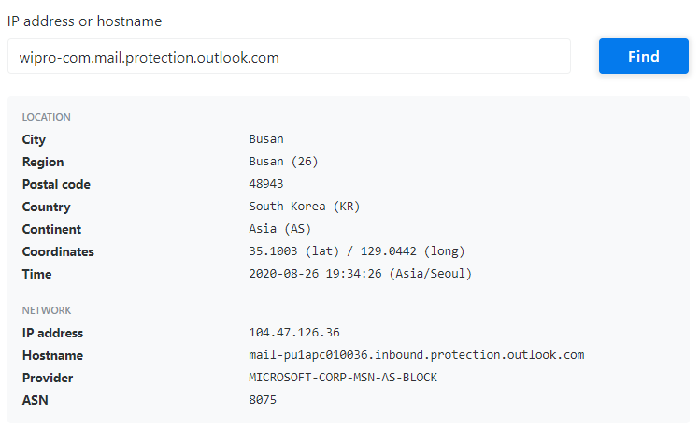

**Question 3:**

Scan and find out port numbers open 203.163.246.23

ANS:-

>Open Kali-pc

>Right click on the screen and Open Terminal

Type:

>sudo su –

> Enter password

>Enter – nmap –Pn –sS 203.163.246.23

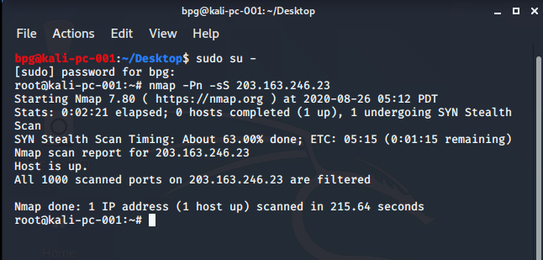

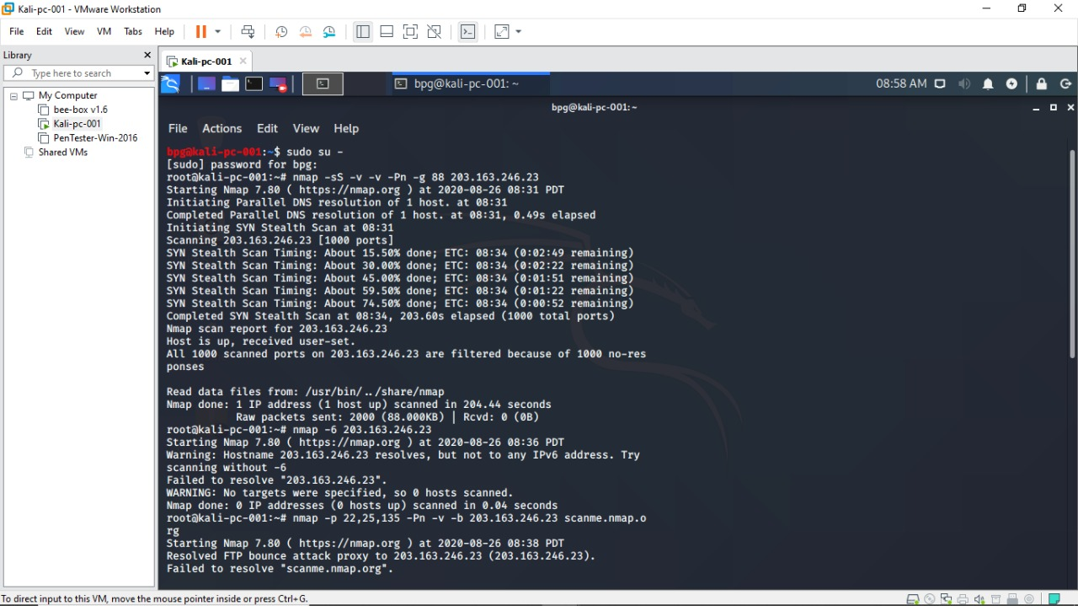

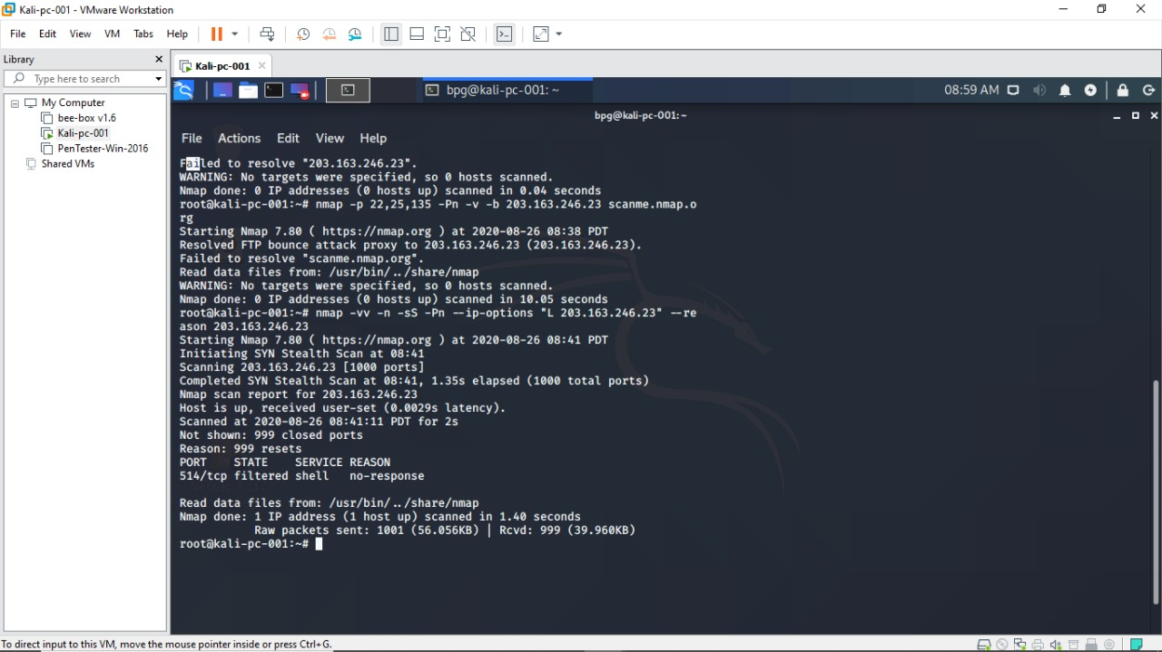

**Question 4:**

Install nessus in a VM and scan your laptop/desktop for CVE

>Open PenTester VMware workstation

>Install Google Chrome

>Install Nessus

>Click on All scans Create a new scan Advance settings Windows Fill the required blanks in credentials as well Launch

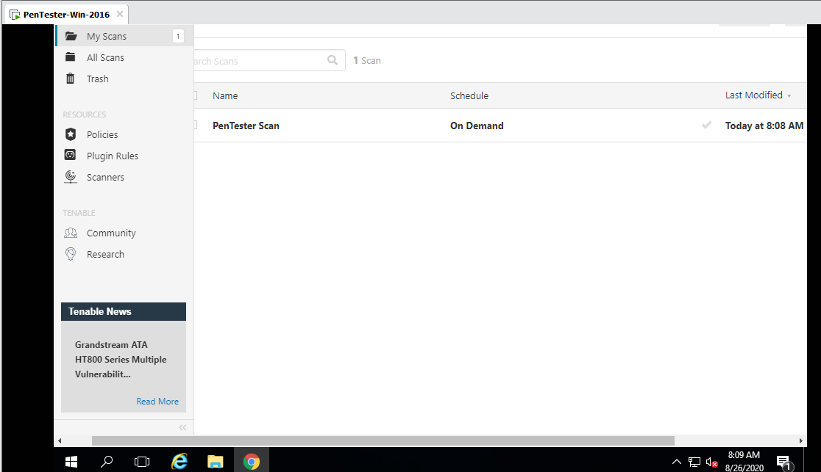

Report:

